**PROOF OF TESTING**

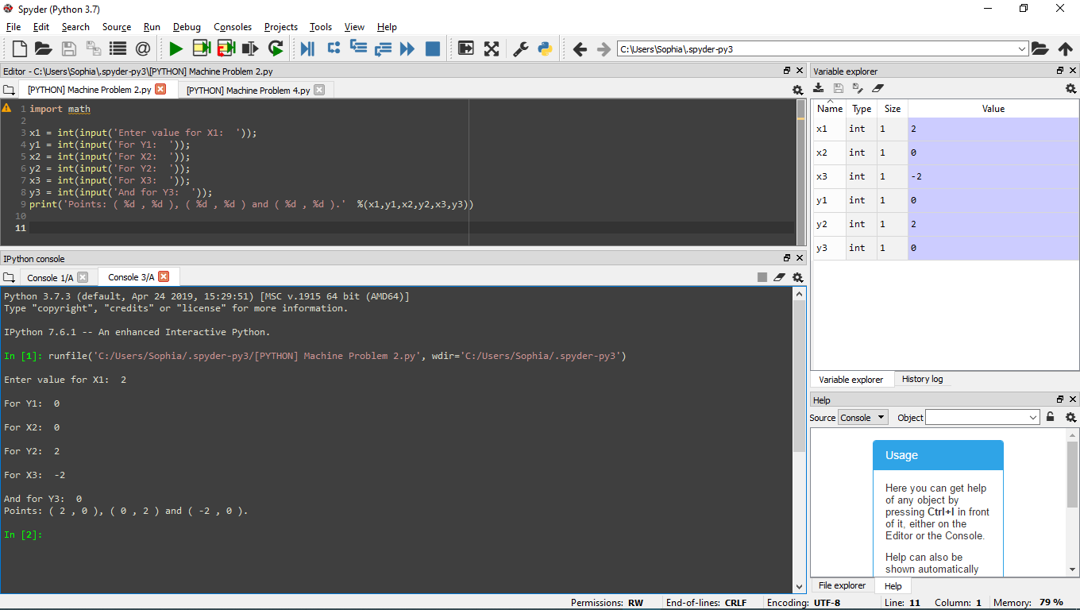**PYTHON Problem 2**

**Request user input points**

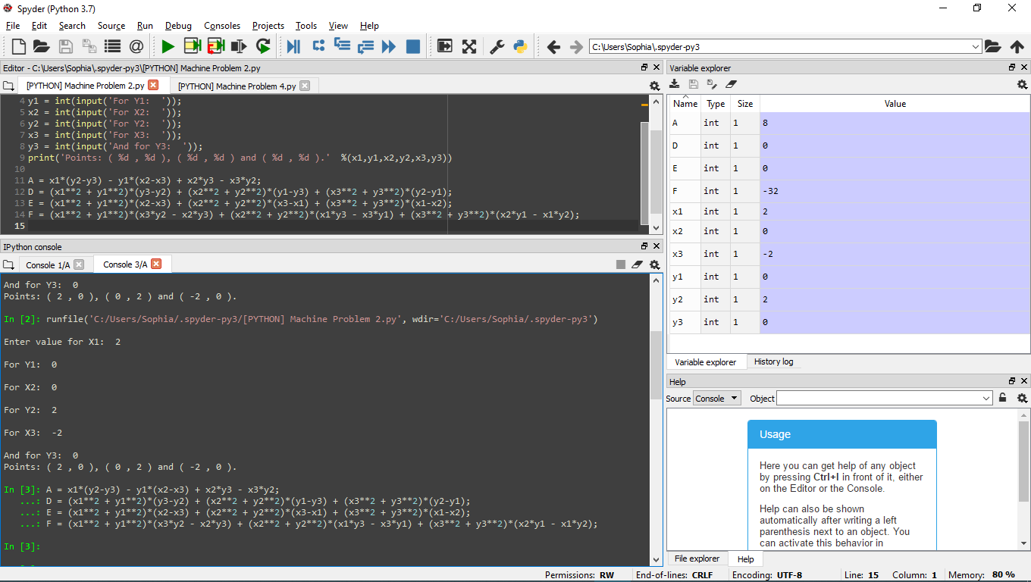

**Values of D, E and F**

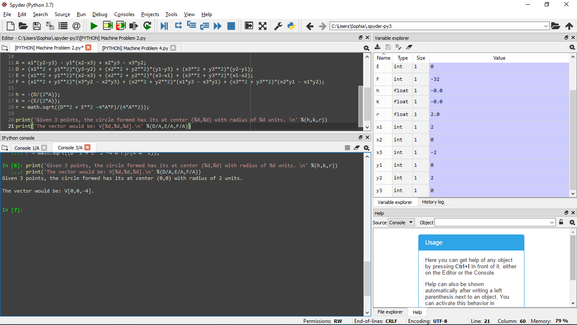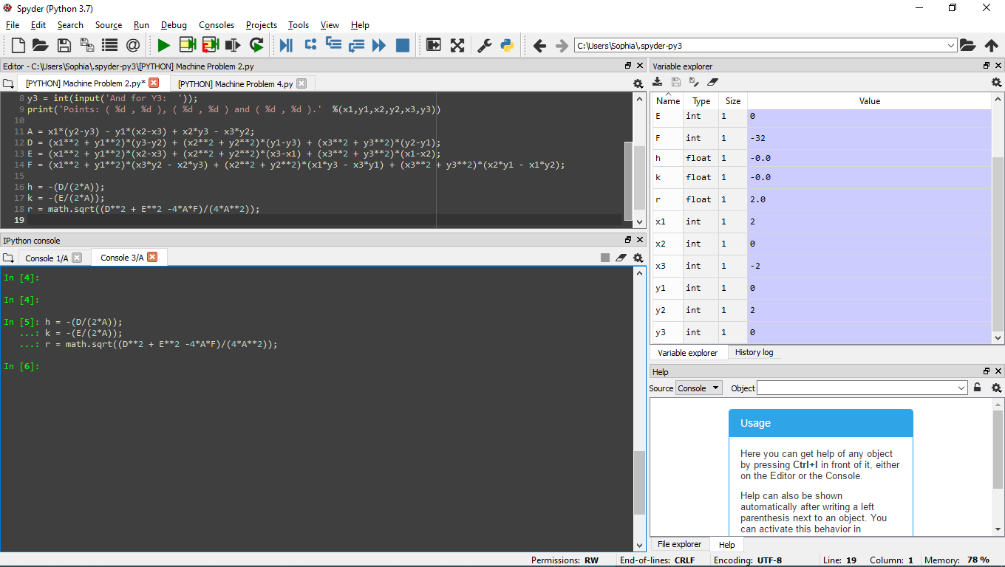

**Print results.**

**Values of h, k and r for center(h,k) and radius r**